**SQL ASSIGNMENT - 6**

**1) Write an SQL query to print details of the Workers who have joined in Feb’2014.**

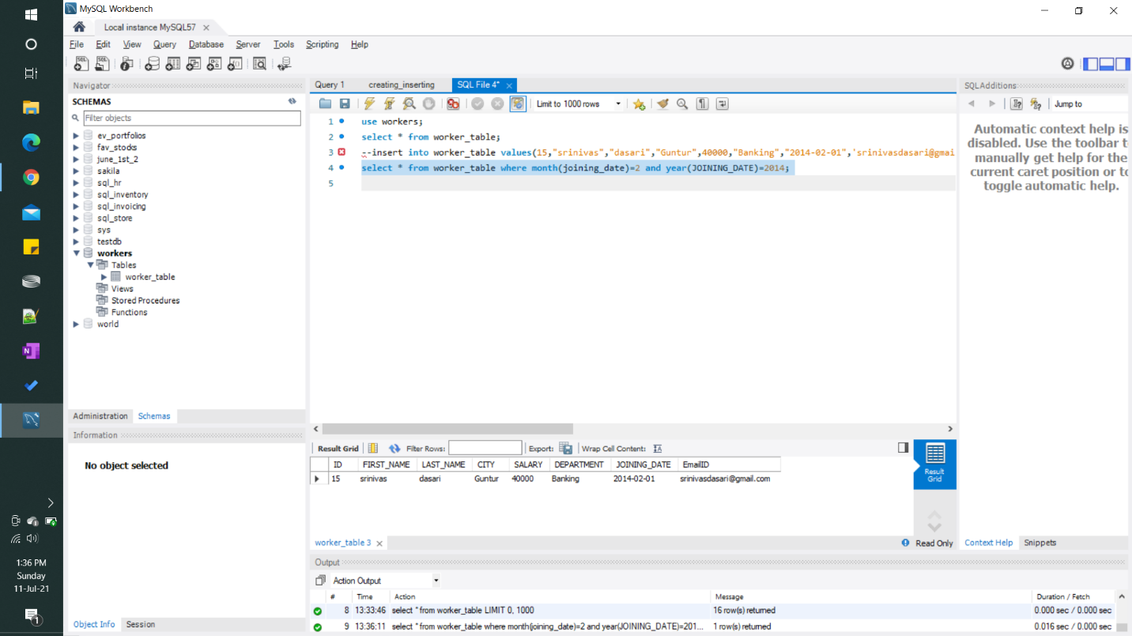

**2) Write an SQL query to fetch duplicate records having matching data in some fields of a table.**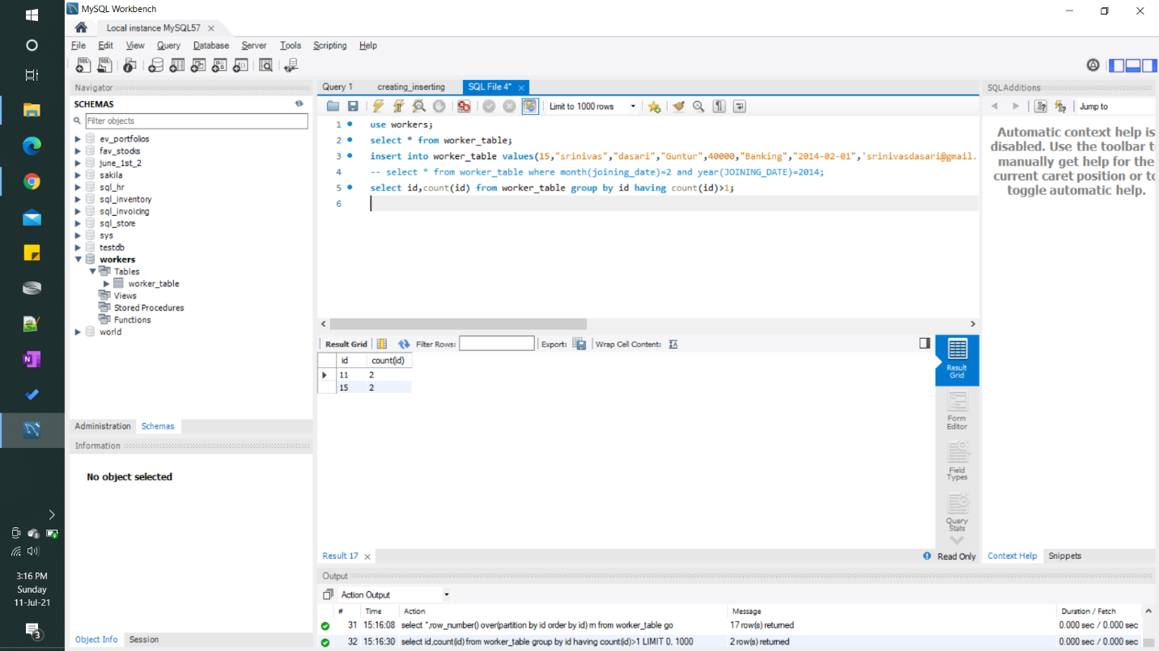

**3) How to remove duplicate rows from Employees table.**

